**Hunger Pains: The Dangers and Concerns of Food Deserts and Food Insecurities in Indiana**

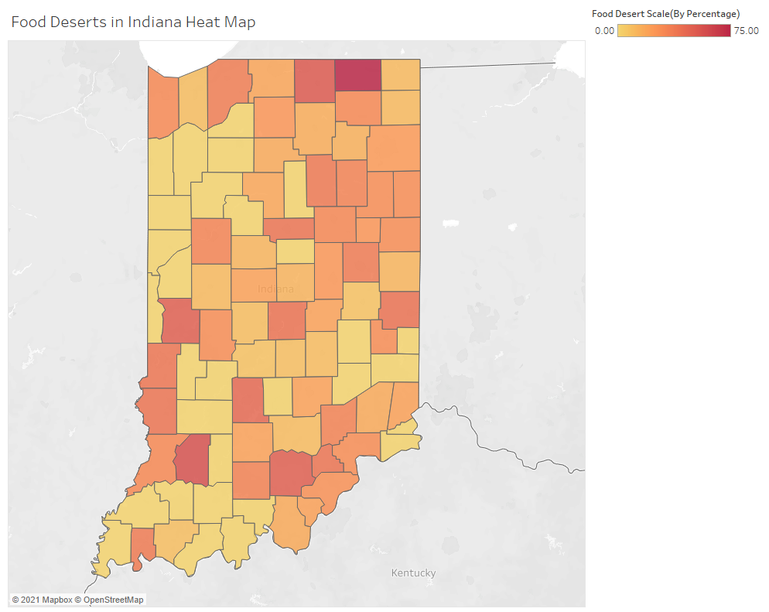

**Team Visualizing Your Data**

| **Name** | **Purdue Email address** |
| --- | --- |
| Megan Jacobs | jacob143@purdue.edu |
| Henry Hutcheson | hhutches@purdue.edu |
| Grace Supancik | gsupanci@purdue.edu |
| Josh Kistler | jkistle@purdue.edu |
| Kassandra Lopez | klopezca@purdue.edu |

Table of Contents

Introduction **4**

Background **4**

Questions **4**

Problem Statement **5**

Methodology **5**

Results **11**

Discussion and Conclusion **15**

References **15**

Appendix A – Resources Used **15**

Datasets 15

Tools used 16

Appendix B – Percent Contribution **17**

Group Contributions 17

Individual Contributions 17

Appendix C – Individual Contributions **19**

Team Member #1: Megan Jacobs 20

Team Member #2: Henry Hutcheson 21

Team Member #3: Grace Supancik 22

Team Member #4: Josh Kistler 23

Team Member #5: Kassandra Lopez 24

Appendix D - Diversity Statement **27**

Appendix E – Team Consensus **28**

Team Consensus 28

Hunger Pains: The Dangers and Concerns of Food Deserts and Food Insecurities in Indiana

# Introduction

Food deserts and insecurities are an incredibly pressing concern, especially in the United States, in which 5.6 percent of the total population resides in a food desert. A food desert, as defined by the United States Department of Agriculture (USDA), is any region that lacks accessibility to sources of healthy food, either due to distance to the nearest grocery store or simply the number of stores in any given area (USDA, 2021). A food insecurity, on the other hand, is a lack of consistent access to enough food for an active, healthy lifestyle (USDA, 2021). There are a multitude of factors that play a role in this determination, including the, “Individual-level resources that may affect accessibility, such as family income or vehicle availability, and neighborhood-level indicators of resources, such as the average income of the neighborhood and the availability of public transportation” (Karpyn et al., 2019). For our hackathon visualization, we aim to bring awareness to food deserts and insecurities in the state of Indiana in the hopes of educating our peers.

# Background

The dataset we chose to pursue for the Hackathon was food deserts and insecurities. Purdue University was classified as a food desert back in 2010 and remained that way until the Target on State Street opened its doors only last year. Since this problem has affected Purdue students so personally, our team thought this would be a prime opportunity to educate our peers about food deserts and food insecurities. We chose to focus on food deserts located in the state of Indiana, and acquired a dataset provided by the United States Department of Agriculture (USDA) that gave statistics related to the total low access population in each Indiana county, as well as the contributing factors to food insecurities, including median income of the area, vehicle availability, and poverty rate. We acquired a second dataset that provided information on grocery prices from the years 2009 to 2020, allowing us to examine market price trends as well as make predictions about future market prices. Integrating both of these datasets into our visualization allowed for correlations between the two factors, grocery prices and food accessibility, to be examined.

# Questions

Our intended audience is people between the ages of 18 to 26 years who are actively navigating the transition into adult life. These individuals are likely gaining more independence and may not know the dangers of food deserts and food insecurities, therefore we feel as though it is our responsibility to educate and spread awareness about the topic. To solve these issues, we wanted to know where food desserts were prevalent in Indiana and what factors are causing this. We felt that it wasn’t enough to know where the problem was so we dug into what caused them. There has actually been very little done for this work in terms of visualization. Especially during our research, on data regarding this topic.

# 

# Problem Statement

While food deserts are a widely researched topic, there are relatively few data visualizations that accurately represent the current statistics and data relevant to the problem in the United States. Much of the existing research was collected using the survey method, which leaves room for nonresponse bias and makes it substantially more difficult to create geographical visualizations. As we discovered during the acquisition stage of the visualization process, there were few food desert and insecurities datasets that offered relevant quantitative data to work with, which is the primary reason why we only used two sets of data for all of our final visualizations. Effectively visualizing food desert data is incredibly important so our peers and other Indiana residents are aware of the dangers and factors that contribute to their development.

# Methodology

Once we identified the problem, we began to acquire the data we needed. We acquired data sets regarding poverty and food deserts, as well as average grocery prices, so that the two factors could be correlated. Once obtaining our datasets, we began parsing the data by removing unnecessary headers and understanding which fields were integers, percentages, categories or strings. We began examining average grocery prices, the range of percentage of poverty in counties, and median family income. The dataset we acquired provided us with an abundance of data that we didn’t need. We originally wanted to focus on examining food deserts and insecurities in the Midwestern states, but quickly realized that would be too broad, and instead filtered the data to include only Indiana counties. Given that our dataset is geographical data, heat maps proved best when providing insight on areas affected with a high poverty rate and areas in a food desert. All group members created their own visualizations with the datasets and as a group, we determined the best attributes of each before deciding on our final visualization. We supplemented our heat maps with bar graphs to better highlight changes in wage and grocery prices over time and therefore provide more valuable insight. Once it was clear more insight was needed, the process was repeated to gather data for grocery prices and wage statistics. After presenting to the class, we took into account our peer’s critiques, such as changing the color scheme of our visualization and to seek outside opinions on our final visualization.

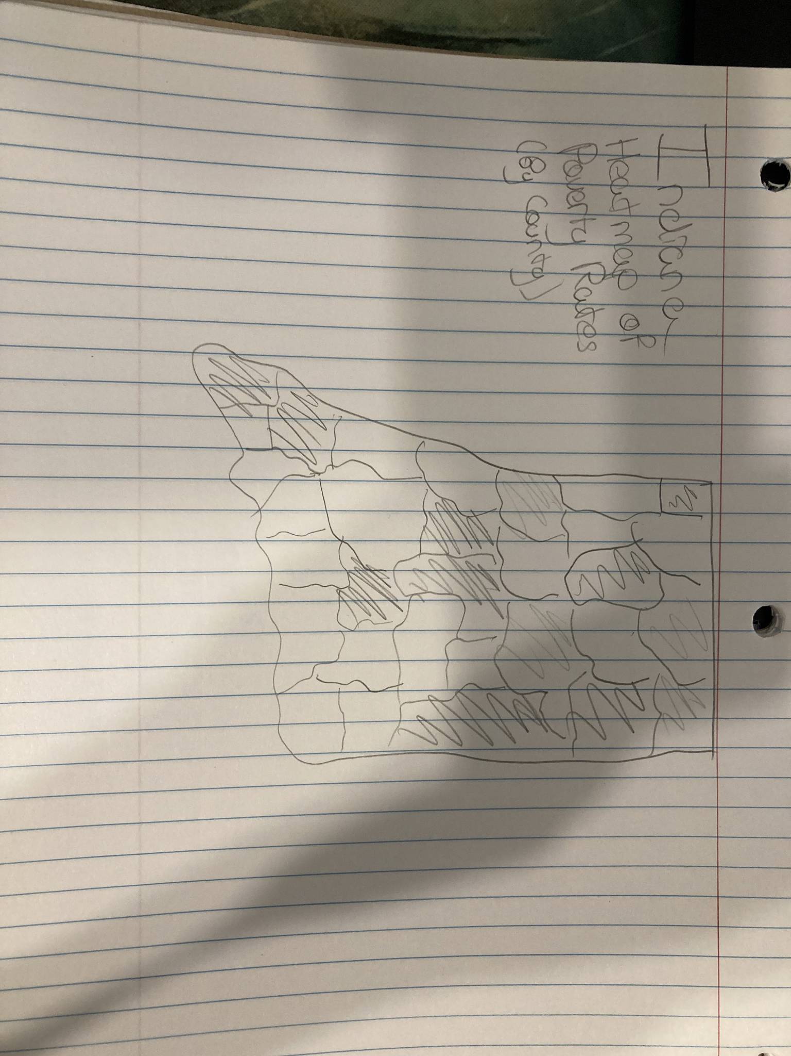

Figure 1.1: This sketch portrays a heat map of Indiana that shows the values of Poverty Rates or Food Deserts by county. This was our initial sketch because it effectively portrays data pertaining to our initial problem statement and the geographical relevance of that data.

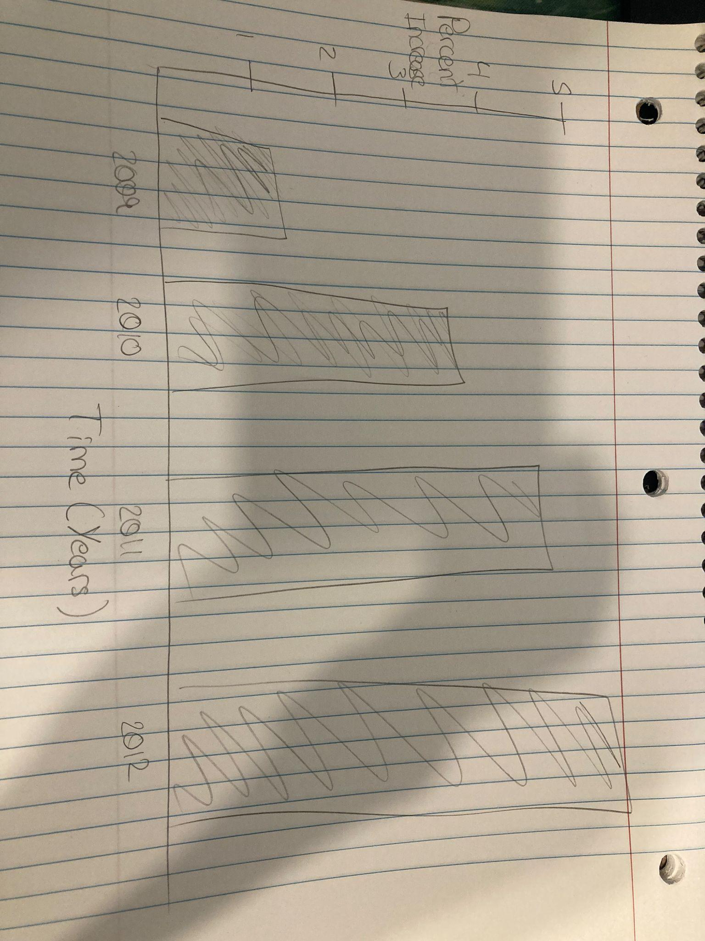

Figure 1.2: This sketch portrays the increase in market prices based off of the CSI(Consumer Price Index) over time. We wanted to utilize this graph to be displayed simultaneously with our geographical visualizations as a possible suggestion for increased rates in food deserts and food security.

# 

Figure 1.3: This sketch portrays a tree map of counties in Indiana, ordered highest to lowest based off of their respective poverty rates. This idea was ultimately scrapped since there wasn’t a large enough difference between the counties with the highest poverty rates and the rest.

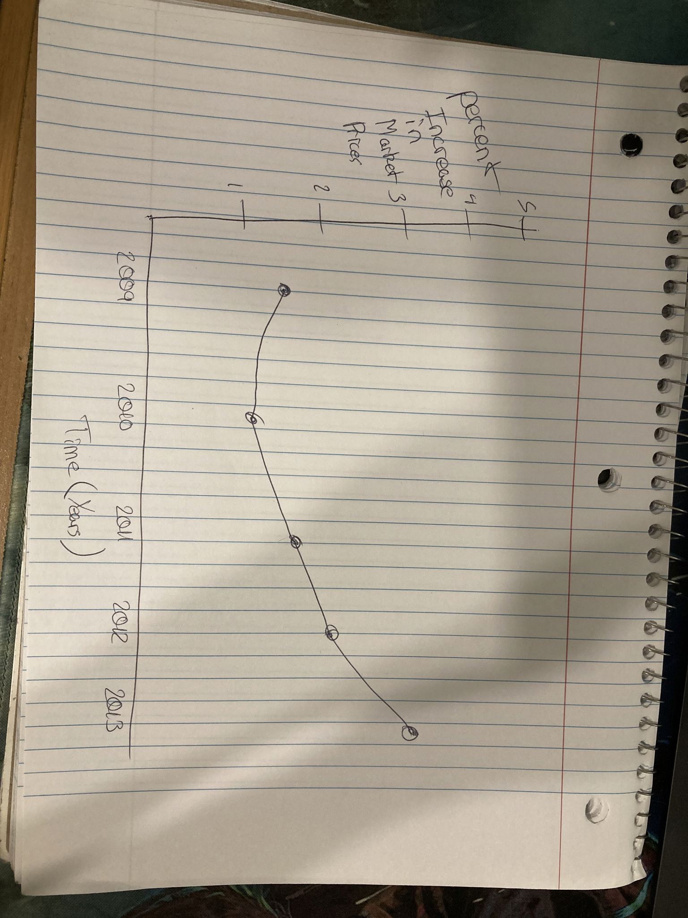

Figure 1.4: This sketch portrays the increase in market prices based off of the CSI(Consumer Price Index) over time. This sketch was scrapped over the bar graph portraying the same data. The bar graph was ultimately better at displaying the grand total of percentage increase at the end of the time increment versus the line graph.

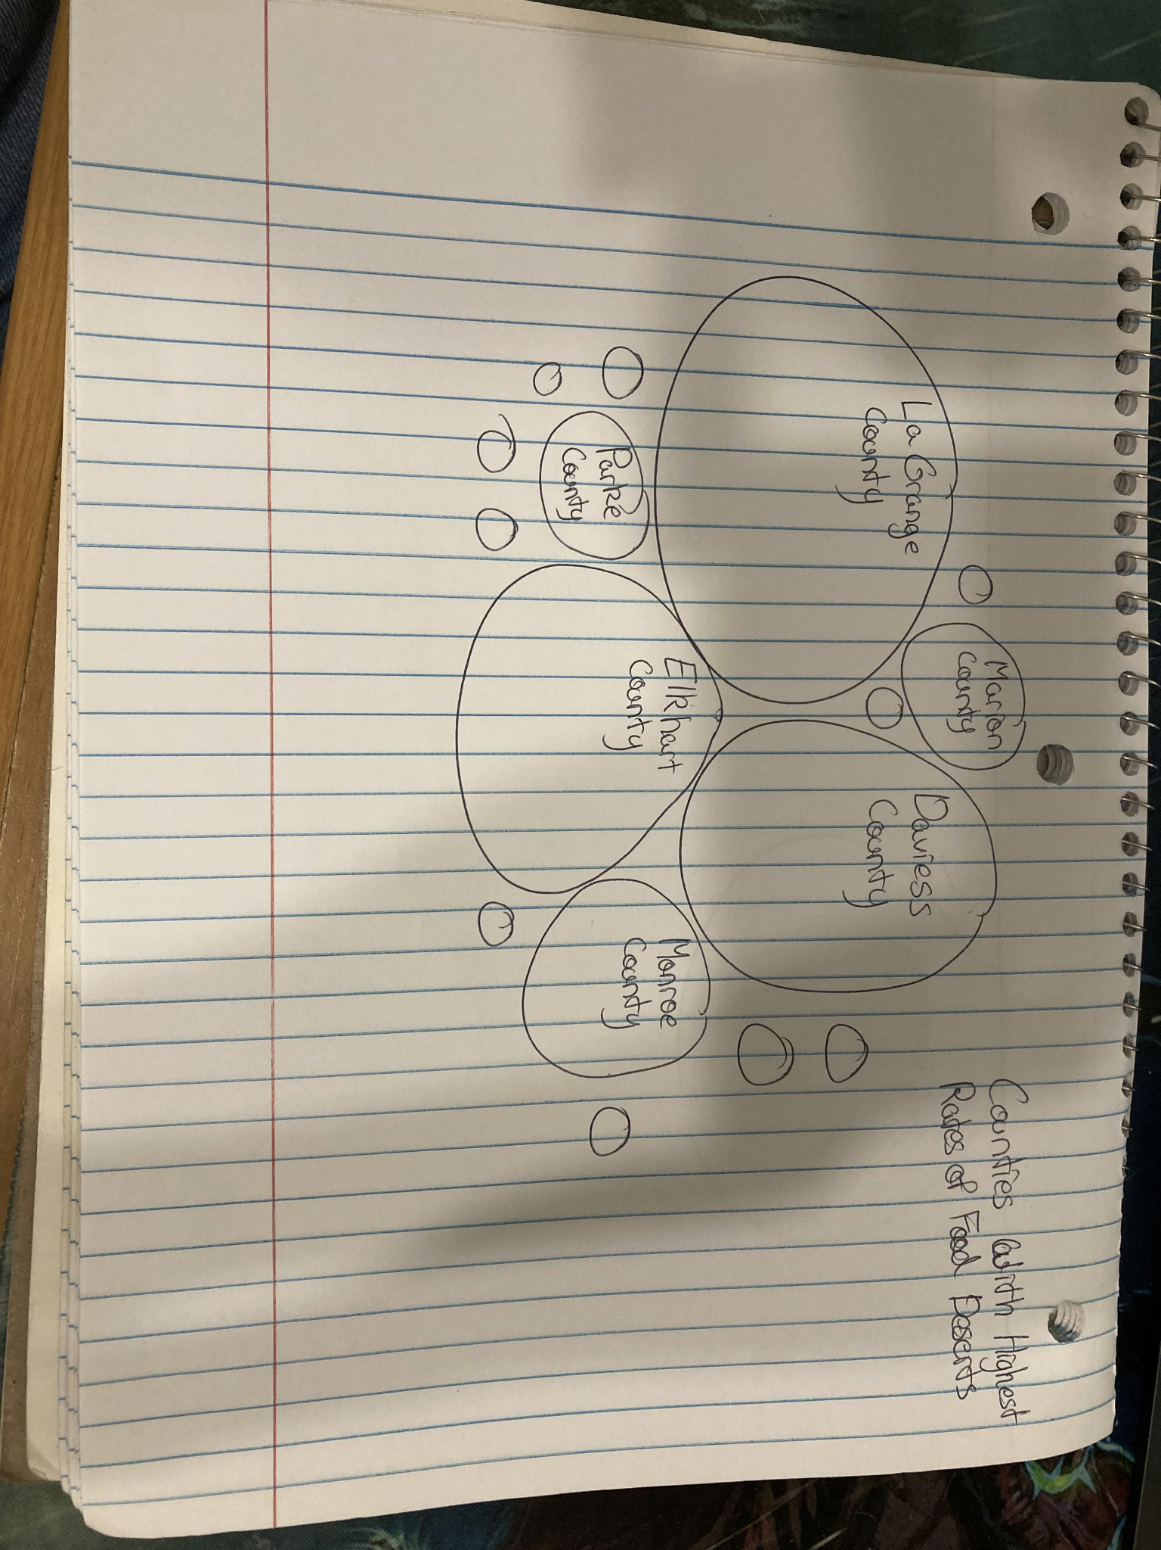

Figure 1.5: This sketch portrays a packed bubble graph of counties in Indiana, ordered highest to lowest based off of their respective Food Desert rates. Like the treemap, this idea was ultimately scrapped since there wasn’t a large enough difference between the counties with the highest poverty rates and the rest.

# Results

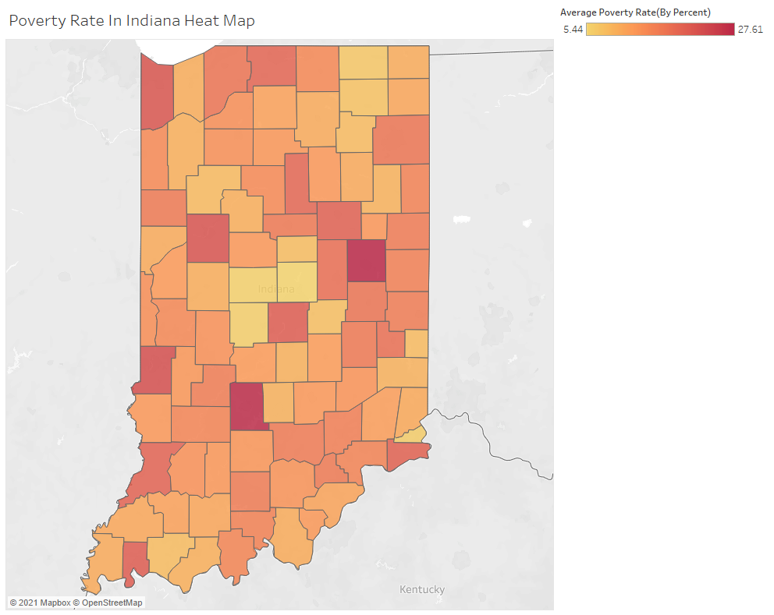

Figure 2.1: This visualization shows the percent value of the poverty rate of each county in Indiana. Smaller values are represented by lighter shades of red and higher values are represented by darker shades of red. The scale begins at 5.44% and ends at 27.61%.

**Created by Joshua Kistler**



Figure 2.2: This visualization shows the percent value of food deserts present in each county in Indiana. Smaller values are represented by lighter shades of red and higher values are represented by darker shades of red. The scale begins at 0% and ends at 75%.

**Created by Joshua Kistler**

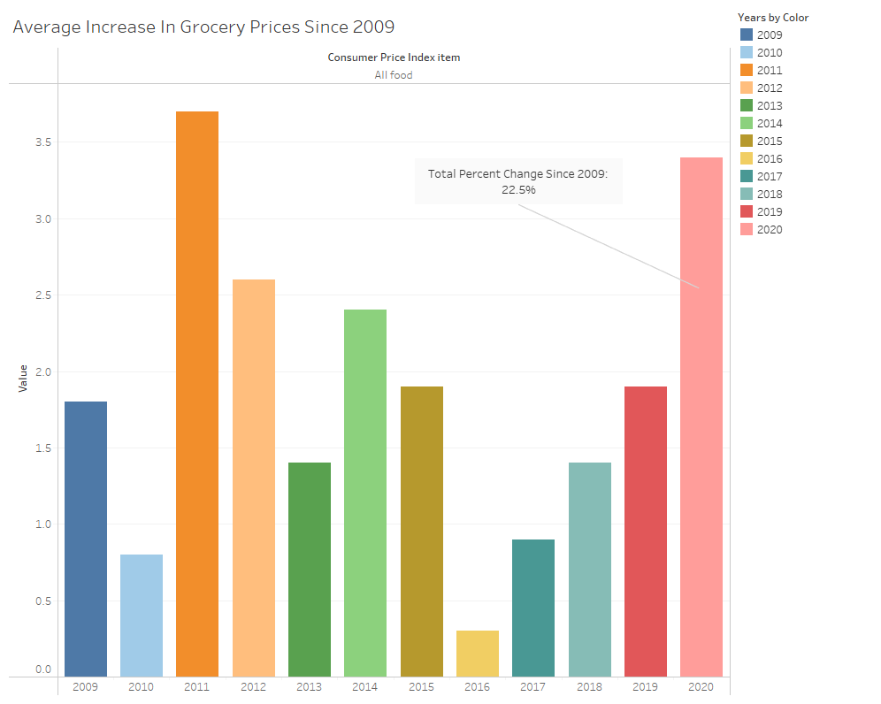

Figure 2.3: This visualization shows the percent increase of market goods based on the Consumer Price Index every year from 2009 to 2020. Each bar represents an increase in percent, adding up to a total 22.5% shown above.

**Created by Joshua Kistler**

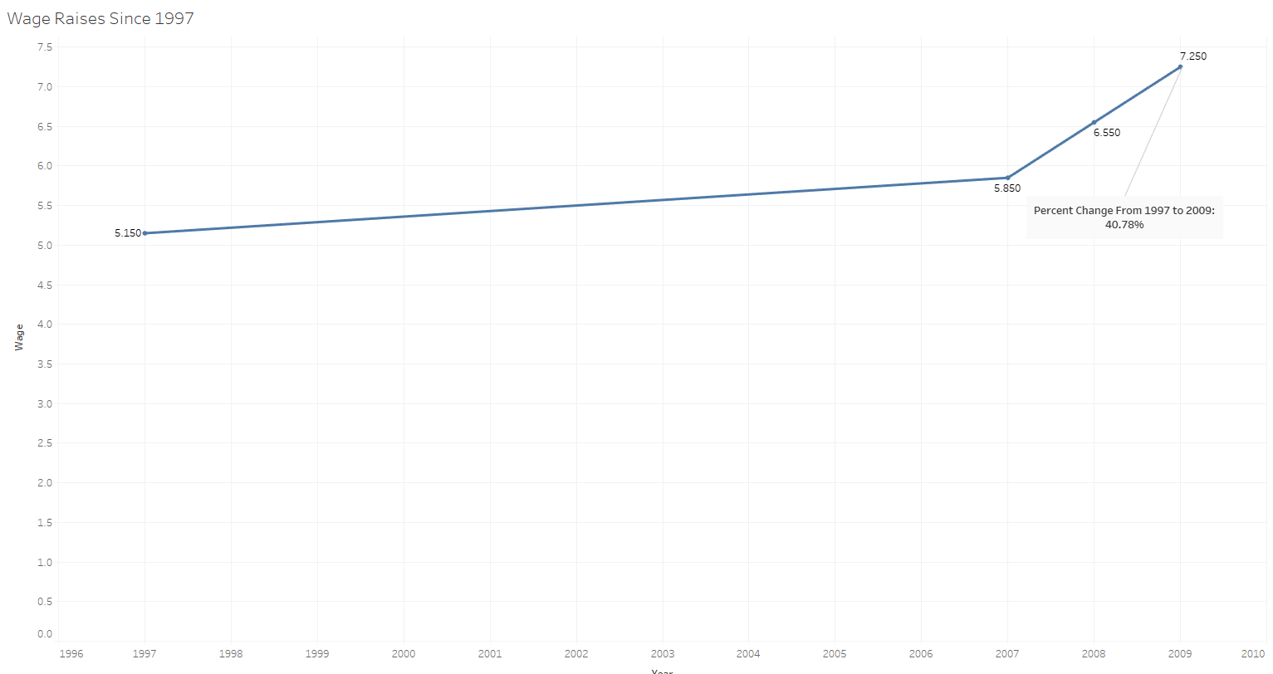

Figure 2.4: This visualization shows the most recent adjustments in minimal wage in Indiana from 1997 to 2010. These years were selected because there has been no increase since the latest value in the graph, which better displays to the viewer how little minimum wage is tampered with in Indiana as a whole.

**Created by Joshua Kistler**

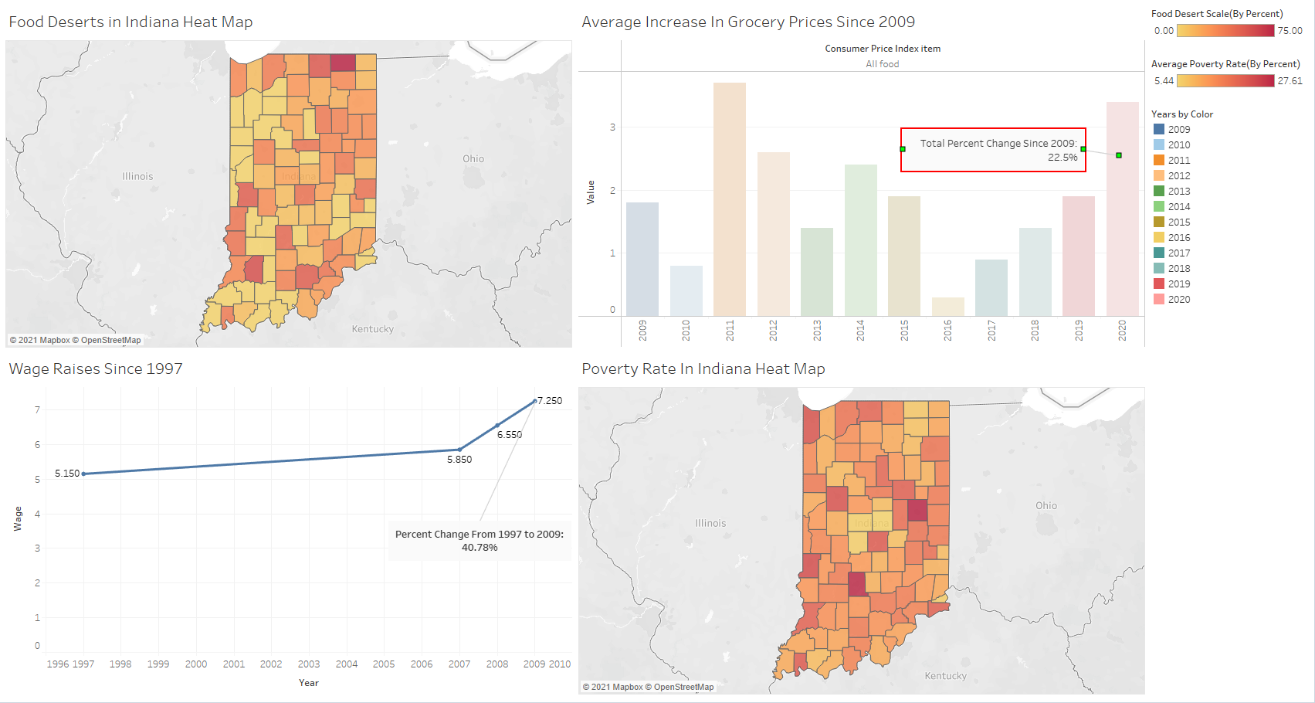

Figure 2.5: This is the final dashboard of all the visualizations being portrayed simultaneously. Through this, the viewer can clearly see how rise in market prices, the stagnant increase of minimum wage in recent years, and how it creates food deserts and poverty throughout Indiana.

**Created by Joshua Kistler**

# Discussion and Conclusion

As we analyzed food desert data, we recognized that the minimum wage of $7.25 per hour has not risen in the state of Indiana since 2008, yet grocery prices have increased substantially, as we saw in our visualization that grocery prices increased by 22.5% since 2009. We also saw a connection between poverty rates and food deserts and food insecurities. This could be because of a multitude of reasons. The United States Department of Agriculture states that areas that have a higher level of poverty are more likely to have food deserts. This could be because of the underdevelopment of business within high poverty areas. This exact scenario can lead to the development of food insecurities. We believe that with our visualizations we do showcase the dangers and the lack of knowledge regarding both food deserts and food insecurities. First, by introducing food deserts within our visualizations and then how they can eventually lead to food insecurities is how we successfully allow others to know more about these two issues.

Due to the fact that this is such a big problem within the United States we recommend a couple of different recommendations. Our first recommendation is to keep bringing awareness to those young adults. The more people are educated about these issues the more awareness and action we can bring to these issues. Also, by educating themselves they can watch out for signs and areas associated with food deserts or high levels of food insecurity. Our second recommendation would be to not to necessarily “fix” food insecurities or food deserts specifically, but to improve upon the factors that cause these issues like unemployment, lack of public or private transportation, and more consistent access to healthy foods such as a community garden, community farmers markets, surplus food sharing, and developments of affordable grocery stores. Finally, our last recommendation would be to have certain policies in place to help bring forth those changes we stated within our last recommendation. For instance, incentivizing development of more consistent access to healthy foods or by expanding programs such as Supplemental Nutrition Assistance Program, also known as food stamps. These are just a few ways we can start turning a new corner on food insecurities and food deserts.

# References

https://www.ers.usda.gov/data-products/food-access-research-atlas/download-the-data.aspx

https://www.ncbi.nlm.nih.gov/pmc/articles/PMC7299236/

https://www.ers.usda.gov/webdocs/publications/45014/30940_err140.pdf

# Appendix A – Resources Used

## Datasets

**Dataset #1:** USDA 2019 Food Access Research Atlas

**Description:** This data set provides an overview of food access indicators for several tracts based on census data that measure food/market accessibility.

**Dataset #2:** USDA Food Price Outlooks

**Description:** This data set provides information on grocery prices from previous years and up to the present, allowing an individual to see market price trends over a period of time and make a prediction on future market prices.

## Tools used

List all tools used in the project and a brief description (see the examples below); add more if applicable.

| **Tool/Application** | **Description** |
| --- | --- |
| Excel | Data cleaning |
| Tableau | Data visualization |
| HTML | Web development |

# Appendix B – Percent Contribution

## Group Contributions

All group members contributed to the data visualization process, brainstormed topic ideas, served as rotating team leader, contributed content to the 5-minute video, edited the final deliverable before submission, and attended all group and lab meetings.

## Individual Contributions

| **Team Member** | **Description** | **Contribution** |
| --- | --- | --- |
| *Megan Jacobs* | * *Created and edited the 5-minute presentation* * *Contributed to critiques and iterative process of creating our visualization* * *Helped developed and maintain group website* * *Created 2 visualizations to help group ideate and find a solution to food deserts and food insecurities* * *Reviewed and edited document before submission* * *Contributed to the hackathon report* | *23%* |
| *Henry Hutcheson* | * *Record section on visualizations and explained importance of them* | *5%* |
| *Grace Supancik* | * *Researched and acquired data sources* * *Filtered and mined one of our datasets so that it could be applied to our problem* * *Responsible for explaining the overview of our problem, introducing the team, and explaining our intended audience in the presentation* * *Contributed to each of the individual assignments for the hackathon* * *Set up website and helped in the initial stages of the website* * *Contributed to the hackathon report* | *23%* |
| *Josh Kistler* | * *Researched and found data sources* * *Put together heat maps and bar charts* * *Oversaw critique and refinement to said graphs* * *Maintained google drive and organized any and all files* * *Contributed to the hackathon report* | *26%* |
| *Kassandra Lopez* | * *Researched datasets for hackathon* * *Added to the presentation* * *Recorded section during presentation regarding insights and next steps* * *Created and maintained google drive and organized any and all files* * *Contributed to the hackathon report* | *23%* |
|  | Total | 100% |

# Appendix C – Individual Contributions

In this appendix each team member must contribute a one-page document relating the team’s topic/data to their hometown or home country. The one-page document must contain: (1) a description of the problem, (2) a comparison of the team’s findings with insights about your hometown/country related to the hackathon data (3) a visualization to support items (1) and (2).

Each person should create their individual page **(1-page only)** and make it available to the designated team member who will upload the final document.

This will be viewed and assessed as part of each person’s individual contribution.

Leave this page as is.

Start adding individual page content on the next page.

REMOVE any blank pages before submitting.

## Team Member #1: Megan Jacobs

My Hometown/City/Country: Shelby Township, Michigan

Hackathon Topic (dataset): Food Deserts and Insecurities

Include your story and visualization below.

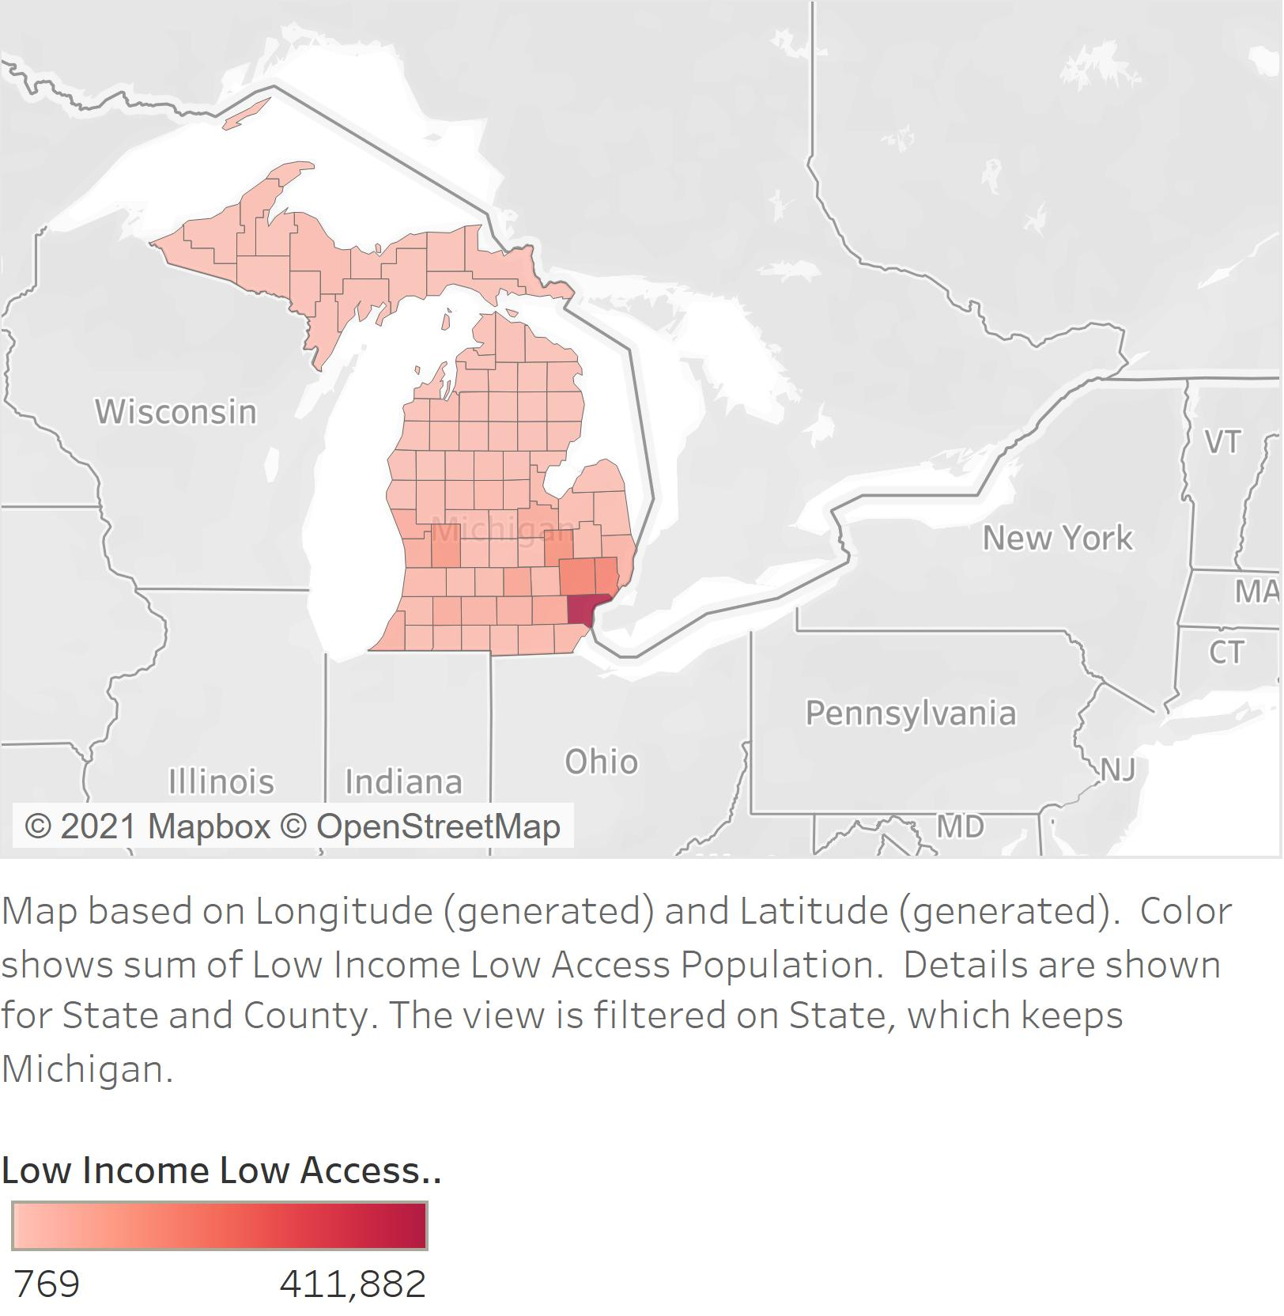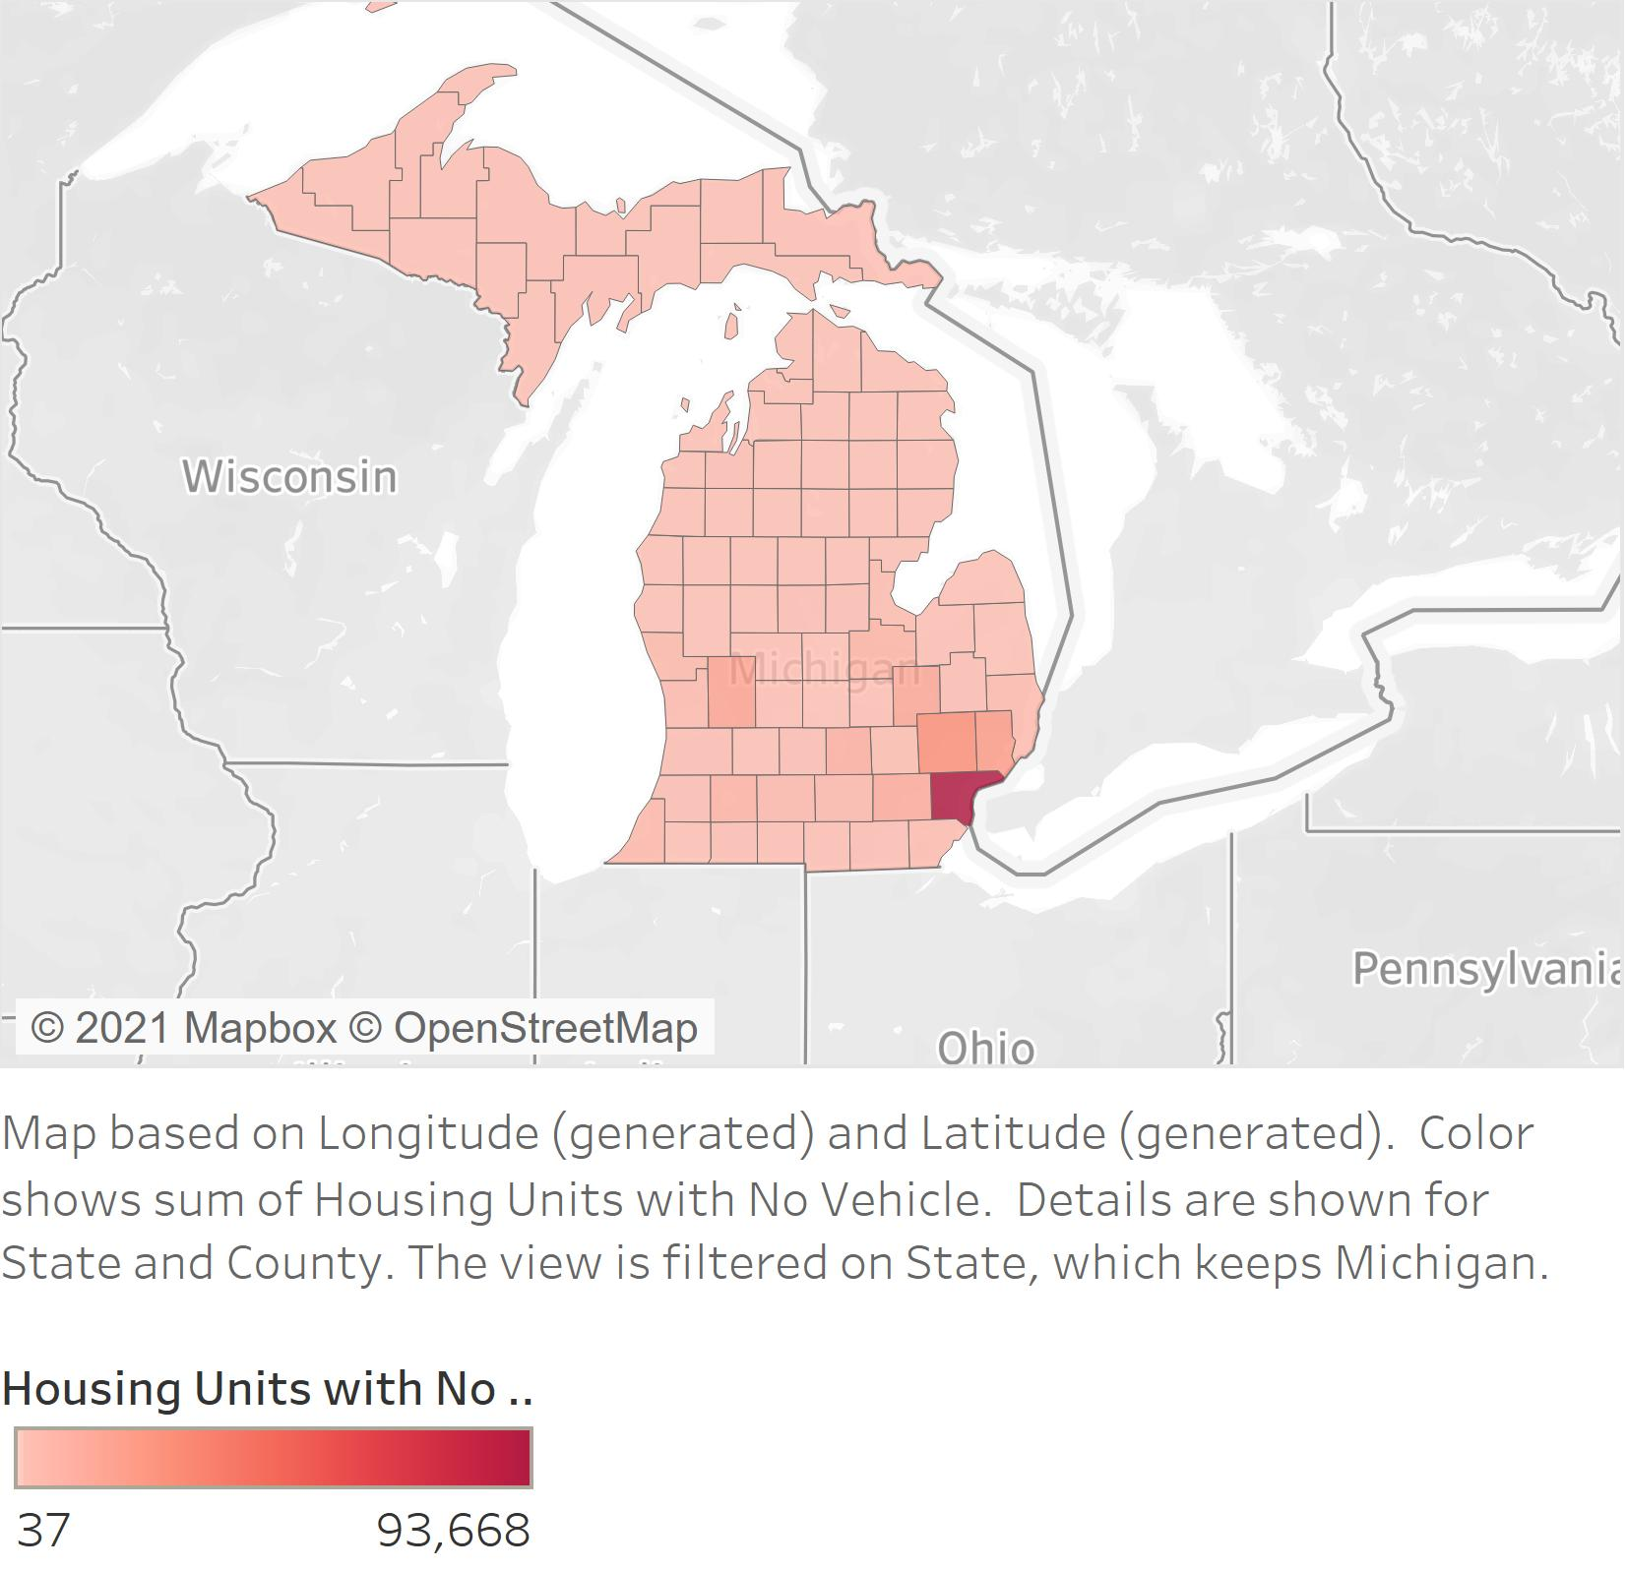

As the only team member from a different state than Indiana, I got to take a look at how Michigan was holding up in terms of food deserts and food insecurities! To reiterate from earlier, we realized that our problem was that not enough young adults were aware of what is going on in America when it comes to food deserts and food insecurities. Food deserts and food insecurities can lead to many negative effects within someone’s life such as mental and physical illness, decrease in cognitive functions, among other side effects. We saw within our insights that due to increased prices in grocery stores as well as due to minimum wages not changing for the past decade. Now compare Indiana’s results to Michigan and we have a similar story. You can see where Warren county is, greatly throughs off the scale for both visualizations. Warren county is circled in red on the visualizations. Warren county has the city of Detroit located in it as well as a majority of the Metro-Detroit area. This could explain why the mapa looks like there are very few areas with food insecurities and food deserts. Similarly Marion County here in Indiana does this when we visualize the data on a heat map. Like Warren County, Marion County has the large city of Indianapolis along with the surrounding suburbs of Indianapolis.

## Team Member #2: Henry Hutcheson

My Hometown/City/Country:

Hackathon Topic (dataset): Food Deserts and Insecurities

Include your story and visualization below.

## Team Member #3: Grace Supancik

My Hometown/City/Country: Fishers, Indiana (Hamilton County, IN)

Hackathon Topic (dataset): Food Deserts and Insecurities

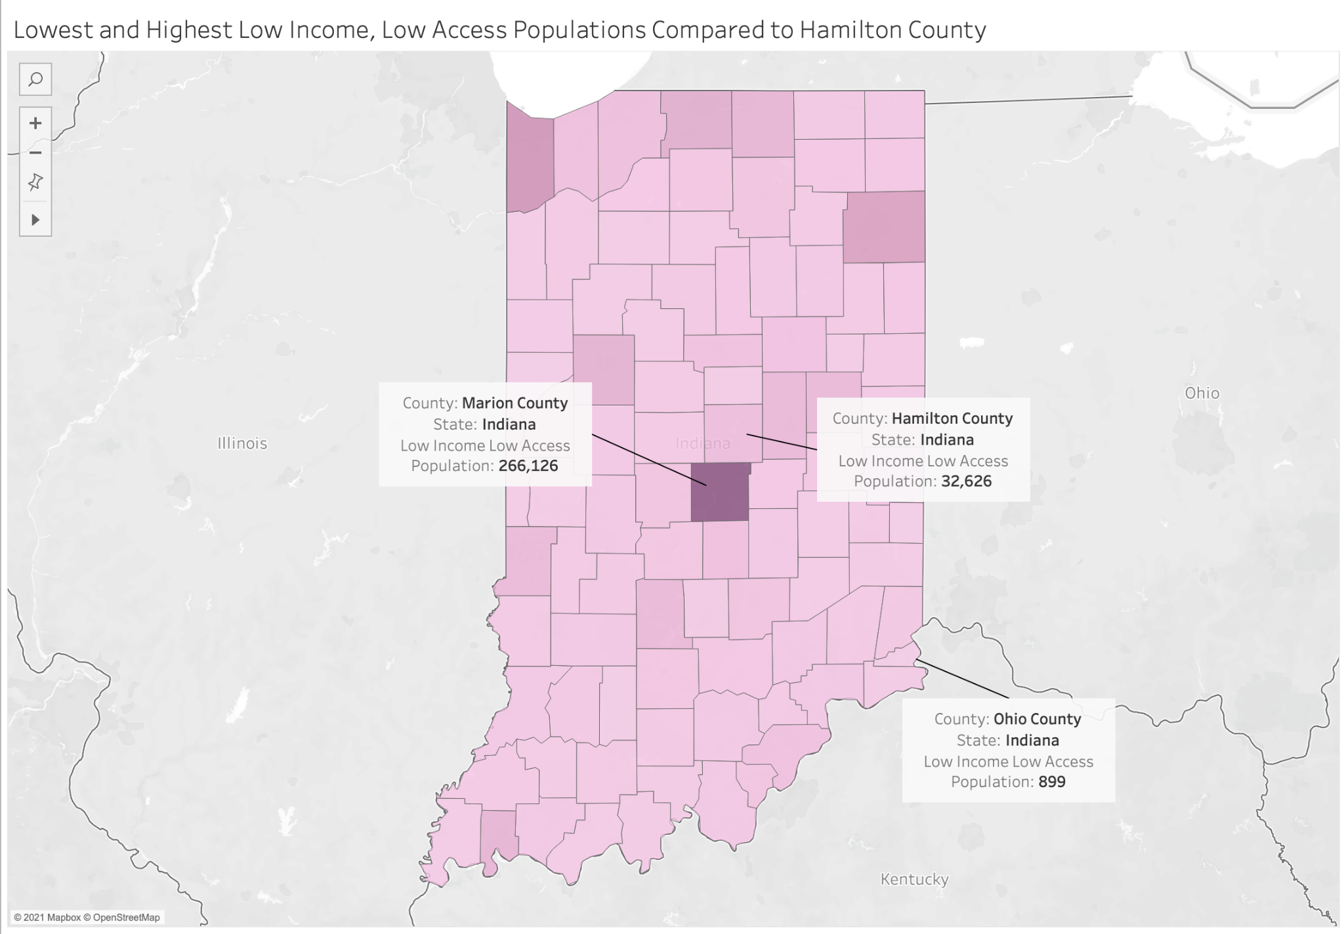

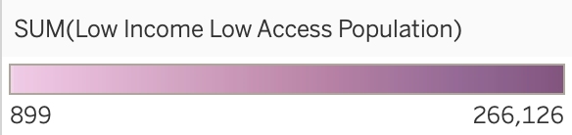

Food deserts and insecurities are a concerning but little-known issue nationwide. Given that food deserts and insecurities affect every single state and every demographic, it is important for…I wanted to address the question of how Hamilton County, IN compares to the lowest and highest low income low access populations in other Indiana counties. This visualization offers insight as to how Hamilton County compares to other counties in Indiana in terms of the population that is affected by food insecurities. I used a color spectrum to better visualize how each population compares between counties in Indiana in which a darker color indicates a higher population and a lighter color indicates a lower population. Marion County is easily the most impacted by food insecurities, which comes as no surprise as urban areas are disproportionately affected by food insecurities, likely due to higher total populations that cause cramped living conditions, as well as limited access to healthy food markets. While the low income low access population of Hamilton County is quite high, Hamilton County boasts a high total population, which indicates that the percentage of low income low access residents to total residents is relatively low, at approximately 12%. This statistic is compared to that of Marion county, which is roughly 29%.

## Team Member #4: Josh Kistler

My Hometown/City/Country: Demotte, Indiana

Hackathon Topic (dataset): Food Deserts and Insecurities

Food deserts, food insecurity, and poverty are a constant concern amongst many individuals and families alike throughout the world due to rising costs of essential goods such as food and water, or simply the lack of access to these necessities. As a member of a low income family growing up, I was also at times subject to the fears of food insecurity. Through all the strife we still made ends meet one way or another, but it was a constant thought in the back of our minds. Many members of my community also struggled with food insecurity, so I thought it might be insightful to examine my county, Jasper County, and the surrounding counties to see if my past challenges were commonplace amongst members of my county. To determine this statistic, I used data from the USDA Food Atlas, and took the value for low income individuals and divided that value by the total population of the county. To my surprise, I found that Jasper County had a low percentage of low income families and individuals, along with other counties around it such as Porter County and White County. Lake County, on the other hand, had a much larger low income population, and a much larger population in general. Lake County is a much more urbanized area compared to its peers, which would lead me to believe that rather than suffering primarily from food deserts, food insecurity comes from lack of proper compensation. This hypothesis is backed by our research on the subject.

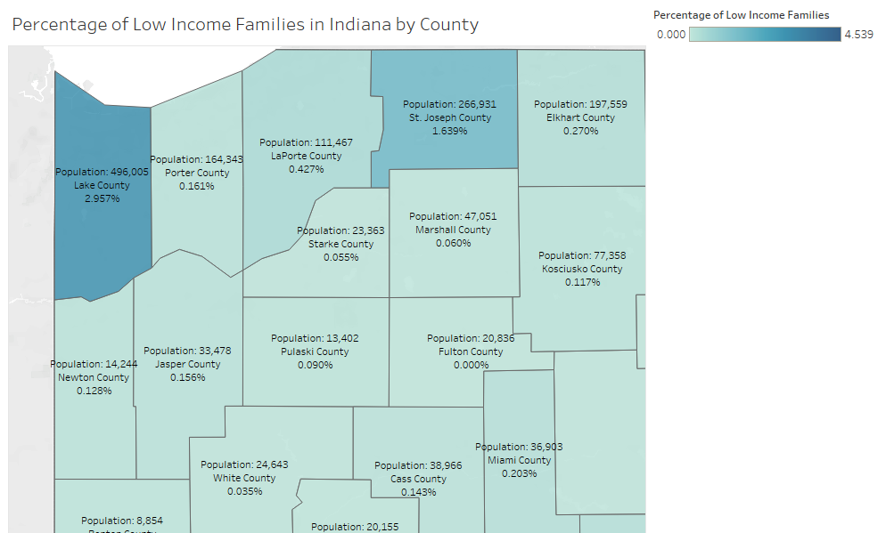

This graph displays information on Jasper County and the surrounding counties. It shows the county population, county name, and the percentage of the population that is considered low income.

## Team Member #5: Kassandra Lopez

My Hometown/City/Country: Frankfort, IN

Hackathon Topic (dataset): Food Deserts and Insecurities

Include your story and visualization below.

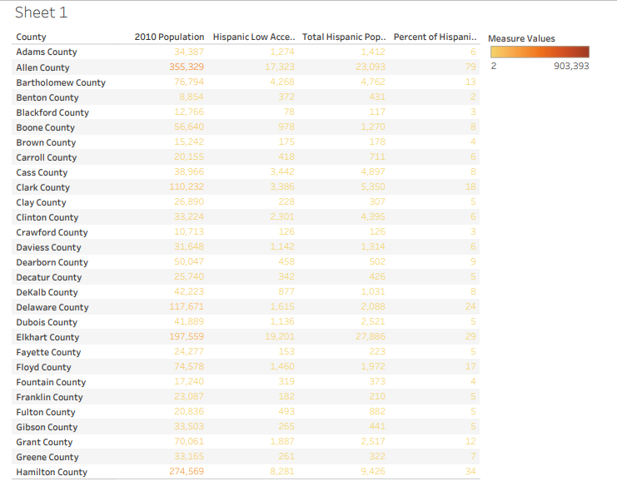

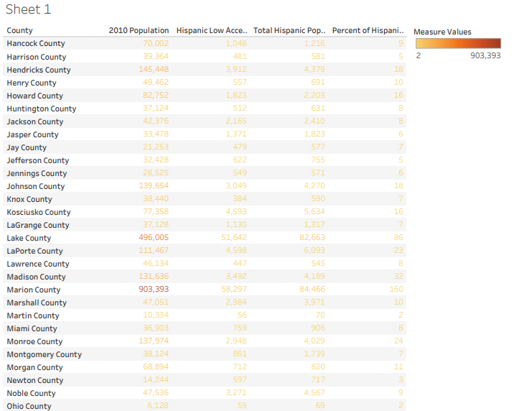

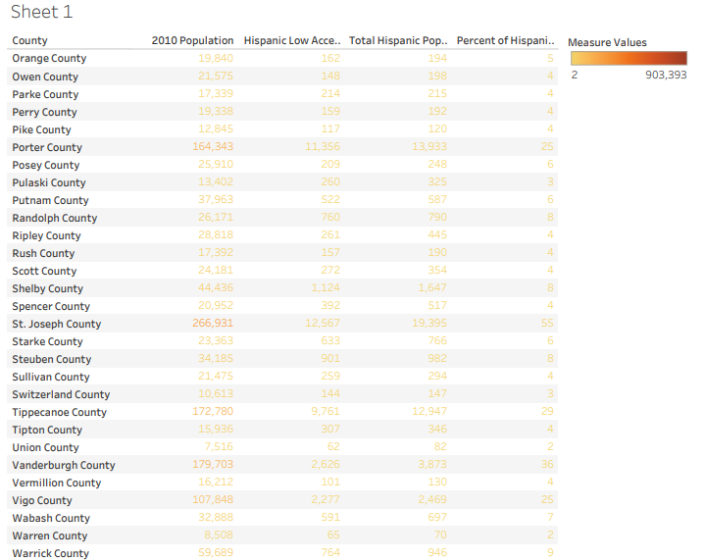

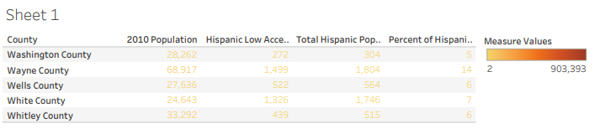

Before the team decided to take an overall approach to our project, I found a dataset that dove into food insecurity for different races across the country. The dataset was narrowed to Indiana and since I’m hispanic, I went through and created a visualization for the hispanic population in the state of Indiana. The final column in this visualization is the percent of how many hispanics have food insecurities in each county. The first three rows are for numerical comparison.

# Appendix D - Diversity Statement

Team Visualizing Your Data has a multi-disciplinary makeup of members majoring in data visualization (Henry Hutcheson, Grace Supancik), web programming and design (Josh Kistler, Megan Jacobs, and Grace Supancik) and UX design (Kassandra Lopez), as well as a few team members minoring in CNIT (Megan Jacobs, Josh Ksitler). Although most of the team members are upperclassmen, the team is represented at nearly all levels of academic status (freshmen, juniors and seniors). Other than different disciplines and academic status, we found that we have different interests, like music and art, outside of class. These differences allow for different perspectives on our project and better problem solving.

# Appendix E – Team Consensus

## Team Consensus

I have read and approved of the content as a representation of the team’s work and my contribution.

| Team Member (full name) | Signature | Date |
| --- | --- | --- |
| Megan Jacobs | Megan Jacobs | 12/10/2021 |
| Henry Hutcheson |  | 12/10/2021 |
| Grace Supancik | Grace Supancik | 12/10/2021 |
| Josh Kistler | *Joshua Kistler* | 12/10/2021 |
| Kassandra Lopez | Kassandra Lopez Carrillo | 12/10/2021 |

*Please note that Henry did not complete his individual work or sign the document on time, so we had to submit it without either.